**Au foil**

12-07-2019 – …../..

PETRA III Extension Beamline P65

XAS CONTINUOUS MODE

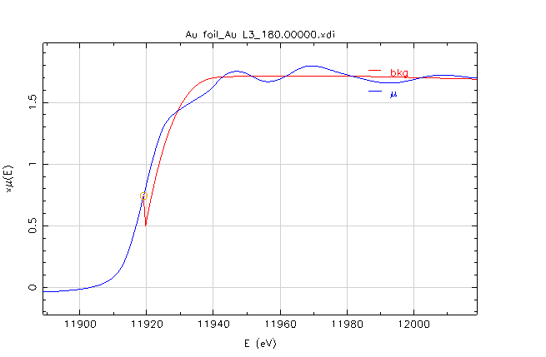

E0 = **11919** eV, Edge step = **1.8**, Pre-edge = -120 to -30 eV, Normalization = 50 to 800 eV

kw = 2

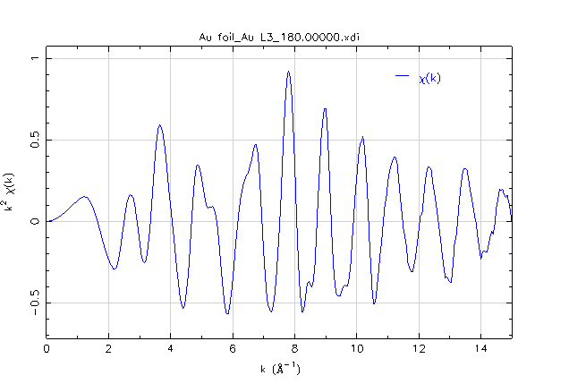

k range = 2.5 – 12.6 Å-1

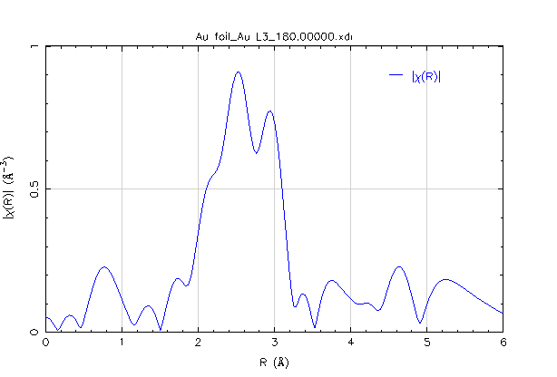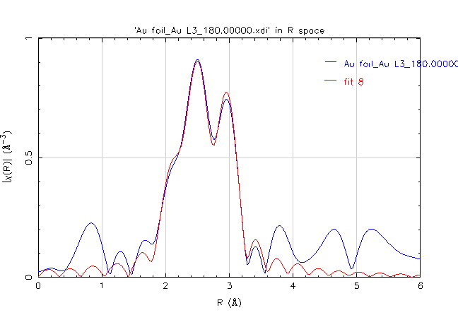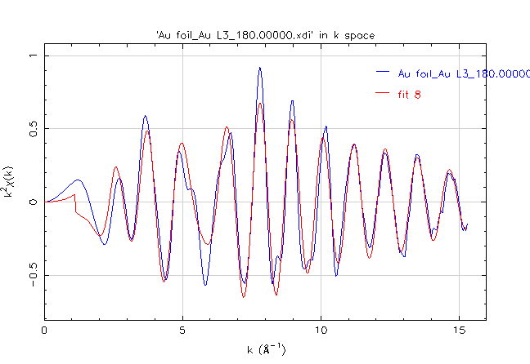

Project title : Fitting Au_foil_Au_L3_180_00000_xdi.chi, This fit at : 16:25:41 on 19 April, 2022

Artemis 0.8.012 using Some Windows OS, perl 5.008008, Tk 804.027, and Ifeffit 1.2.11

Independent points = 12.060546875

Number of variables = 4.000000000

Chi-square = 1050.139129101

Reduced Chi-square = 130.281374873

R-factor = 0.002924300

Guess parameters +/- uncertainties (initial guess):

**amp = 0.7341650 +/- 0.0427810** (1.0000)

enot = 4.7674890 +/- 0.4297150 (0.0000)

delr = -0.0237510 +/- 0.0029900 (0.0000)

ss = 0.0075740 +/- 0.0004150 (0.0030)

k-range = 2.493 - 12.032 dk = 1.000 k-window = hanning k-weight = 2

R-range = 1.495 - 3.513 dR = 0.000 R-window = hanning fitting space = R

FEFF0: Path 1: [Au1_1] .. id = reff= 2.8850, nlegs= 2, path= Au<->Au

r = 2.861249

degen = 12.000000

s02 = 0.734165

e0 = 4.767489

dr = -0.023751

ss2 = 0.007574